cid:image001.png@01D17F9C.06CBCBA0

**UNIVERSITY OF COLORADO COLORADO SPRINGS**

**Small Construction Standing Order Contractors Purchase Program (SOC) List**

**2021-2026**

**Project Number: 21-010**

**Frequently Asked Questions**

1. **Do we need to submit forms SC-6.21 and SC-6.23 along with the rest of the submittals?**

UCCS Response: No, these forms do not apply.

1. **Our firm is a manufacturer representative. We work on local projects directly and manage all the orders, quotes and project management. We also provide additional services. Do we just need to apply as a stand-alone firm or does the manufacturer also need to apply?**

UCCS Response: Your firm only needs to apply.

1. **Our firm carries all of the insurance coverage listed, except Umbrella, Excess Umbrella Liability and Contractor Pollution Liability. Are those coverage areas always required?**

UCCS Response: These are standard insurance requirements. However, please note that Contractor’s Pollution Liability is required for Asbestos/Lead Abatement/Mold Remediation contractors only.

1. **We are a woman owned/controlled business, however not certified as one. Is certification required for the WBE classification on the CU W-9 and Vendor Authorization Forms?**

UCCS Response: Certification required for WBE classification.

1. **Our services for signage are below $50,000. Please clarify project bonding requirements. Please clarify what we need to provide to confirm our bonding capability.**

UCCS Response: For projects greater than $100,000 – performance, labor and material bond required. For projects greater than $50,000 – bid bond required. Provide documentation from its Surety, clearly indicating its full bonding potential against bonding commitments. Painting contracting firms are not required to provide proof of bonding ability with this RFP submittal. Proof will be required on a per-project basis.

1. **Corporate Seal – our firm doesn’t have a seal, how should the documents requiring a seal be prepared?**

UCCS Response: If your firm does not have a seal, then note that on the document requesting a seal.

1. **If we have additional subsidiaries that are under the parent company, do we need to submit a separate submittal for each subsidiary?**

UCCS Response: Yes each entity under a parent company needs to provide a separate submittal including the CU W-9, Certification and Affidavit Regarding Unauthorized Immigrants, and Certificate of Insurance information. IE. If you are a general contractor, however own a separate painting company with a different name, then that painting company also needs to submit. This is due to PO’s being issued for different projects under the company performing the work.

1. **Explain the CU-W9 process, what to provide for documentation, etc.**

UCCS Response:

For Existing CU Vendors:

If you know you are in the system, go to the PSC page and create an account to access your vendor profile (NOTE: being in the system as a vendor is a *different* thing than having an account); this will let you update your account if any company information changes.

Once you access through the PSC system, you will see it as a Supplier. Below is an example.

For the CU-W9, we need you to provide the “supplier #”. Simply write this Supplier Number on a sheet of paper so we can confirm.

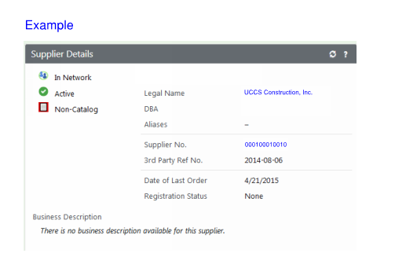

For new CU vendors:

You must register at the below website and complete the form.

<https://solutions.sciquest.com/apps/Router/SupplierLogin?CustOrg=Colorado>

Once you complete the form, simply acknowledge on a piece of paper that you have registered your company on the website. You do not need to provide any other documentation. The process will move forward if you are accepted on our list. At that time, we go into the PSC system and accept that the firm is allowed to become a vendor.

**Any further questions or if you are having issues with this – please contact Deanna Livengood at [dlivengo@uccs.edu](mailto:dlivengo@uccs.edu)