4. Design Guidelines – West Campus

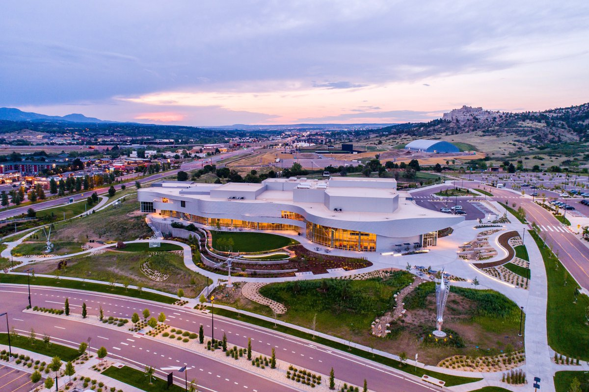

Pulpit Rock forms the backdrop for the Ent Center for the Arts,

Mountain Lion Park and the Indoor Practice Facility

Previous sections of this guideline provide a tangible base for the design of the West Campus as it grows from the modest current development to build-out. The Introduction speaks of the ingredients of scale, style and delight which can make a university campus a special place. Section 1 names the land upon which UCCS is building as the most powerful influence on design for campus facilities. Elements of the built campus, which create a sense of visual continuity from one end of the campus to the other, are discussed in Section 2. Section 3 deals with campus design elements which are specific to the mostly built-out Central/East Campus.

THE FACILITIES STRATEGIC PLAN

The Facilities Strategic Plan adds to this knowledge base. It provides two “snapshots-in-time” for the West Campus of the future. The five-year plan (2006 – 2011) illustrates the facilities UCCS must have to serve an enrollment of 9,100 head count. A head count enrollment of 15,000 is projected by 2021, requiring consider-able construction on the West Campus. There are maps of these plans on pages 4.4, 4.5, 4.8 and 4.9.

It is important that the nature of the Facilities Strategic Plan be clarified in order to understand its relationship to these Design Guidelines. Long-range plans, whether the Strategic Plan for UCCS or a plan for any other campus, are a glimpse into the future…a future that proves more and more uncertain with the passage of time in our fast-changing world. Thus, for example, while the five and fifteen-year plan drawings, which show actual buildings, roadways, and many more details may seem to be very specific, they are actually quite vague. The intent is to illustrate the zones in which certain buildings and other elements are expected to be located, not the specific location and shape of each building or road. Working within the general parameters established by the Strategic Facilities Plan, it will be left to “micro-master plans” based on far more extensive and current knowledge about such matters as institutional needs, complexities of the site including topography and sub-surface soil conditions and much more in order to provide more details for use by designers of individual facilities.

The WEST Campus / Fifteen-Year Plan

The West Campus presents UCCS a wonderful opportunity … and the need to make many design decisions. This section of the Campus Design Guidelines considers those critical decisions.

There is a strong desire among the people of UCCS that the Campus must create a “sense of place” … that it should be a very special environment that speaks articulately of the University’s mission, and the role it plays in the culture of the community. This begins with the distant view of the campus where the very slope of its land resting above much of the City makes it extraordinarily visible. The West Campus design can build upon that very theme, creating a sort of “hillside villages” resting at the base of Austin Bluffs and Pulpit Rock.

Nevada Avenue and University Village Shopping Center

North Nevada Avenue forms the western boundary of the UCCS property. This major thoroughfare, with its landscaped medians, provides multiple access drives to the campus. In addition, a pedestrian/bicycle underpass, just north of Eagle Rock Road, provides a welcome connection to the University Village Shopping Center and the Greenway Trail network.

The West Campus is organized into a series of Villages. An Athletics Village, Arts Village, and a Health and Wellness Village are all identified in the 2012 Master Plan. In addition, Mesa Village, located between the Central and West campuses, is planned with unidentified building uses.

The buildings on the West Campus are ones which are programmatically more connected to the City of Colorado Springs. Rather than just academic, residential or recreational buildings, this area supports the 'town and gown' interface with the city. Providing a welcoming experience for these campus visitors is critical to the success of this area. Additional signage may be necessary to help the community navigate the West Campus.

Nevada Avenue borders the West edge of the campus, along with the University Village Shopping Center. Because the outside public will approach from access points along this major corridor, perimeter buildings may require two entrances. One entrance will serve the public while the other will accommodate the campus community approaching from the east.

Consistent material use is necessary to maintain visual continuity with the Central and East Campuses. The stucco, brick and glass styles should be utilized as per the programmatic use of each building.

Ent Center for the Arts

Anchoring the West Campus is a single 'signature' building: the Ent Center for the Arts. This building was designed as a prominent departure from the building styles used throughout the campus. Its curved, smooth, metal panels reflect the natural light and change hues throughout the day. In order to maintain the distinct character of this building, use of similar materials on other buildings is to be avoided.
Site furnishings at the Ent Center also deviate from the campus standard. Unique bike racks, benches, umbrellas, chairs and trash/recycling receptacles have all been selected to complement this unique building. Care should be taken to preserve the unique nature of this distinct building.

West Campus perimeter buildings must have two “front doors,” one to the Nevada Avenue side and the other toward the campus it serves.

The landscape at University Village will be more formal than at other campus locations. There will be grass, flowers and deciduous and coniferous trees.

A micro-master plan should be prepared for University Village before designs for any individual building are prepared.

University Village is a high-density urban place which offers wonderful design opportunities.

Sports Village

This is the land of the “big box” buildings and green grass sports fields. Its location along North Nevada Avenue makes it convenient for off-campus visitors and is highly visible to the passerby. (See the map on page 4.8)

The multi-purpose arena, field house, and natatorium will be by far the largest building on the campus. While there is no doubt of its importance, this is, after all, an academic institution. Thus, in the hierarchy of buildings, it should not seem to be more important than such nearby buildings as those in the University Village and Research Park.

The architecture of this huge structure must play down its size. This can be accomplished by making it seem to be a cluster of smaller buildings that have been joined together, by building it into the slope of its site and by using roofs which slope down to the building perimeter.

As UCCS grows, it may be necessary to increase the seating capacity of the arena and other sports buildings. This possibility must be considered in their original design.

While the terrain of the site selected for this building is not as steep as that on the sports fields nearby, the change in elevation within the building’s footprint appears to be 20 feet to 25 feet. This, along with the Strategic Plan’s call for automobile parking under the building, complicates its design and ultimately increases its cost consider-ably.

The sports building houses exciting events. The architecture should reflect that with forms that are creative and, while in the brick style, adds areas of metal and glass to express its variety of functions, its entrances and views of activities within.

The Strategic Plan shows large sports fields on land where the slope reaches nine percent or so, requiring significant earthwork. This is made an even greater problem since the plan places these fields and courts perpendicular to the contours.

Site designs for this area should consider placing these large, basically flat fields and courts parallel to the contours, thereby reducing the steep grades required.

If the grades of this area permit, native grasses should be seeded between the turf fields. Native tree species should also be used. Special consideration must be given to surface drainage.

Like all other villages on the complex land, a micro-master plan is needed prior to design of individual facilities at the Sports Village.

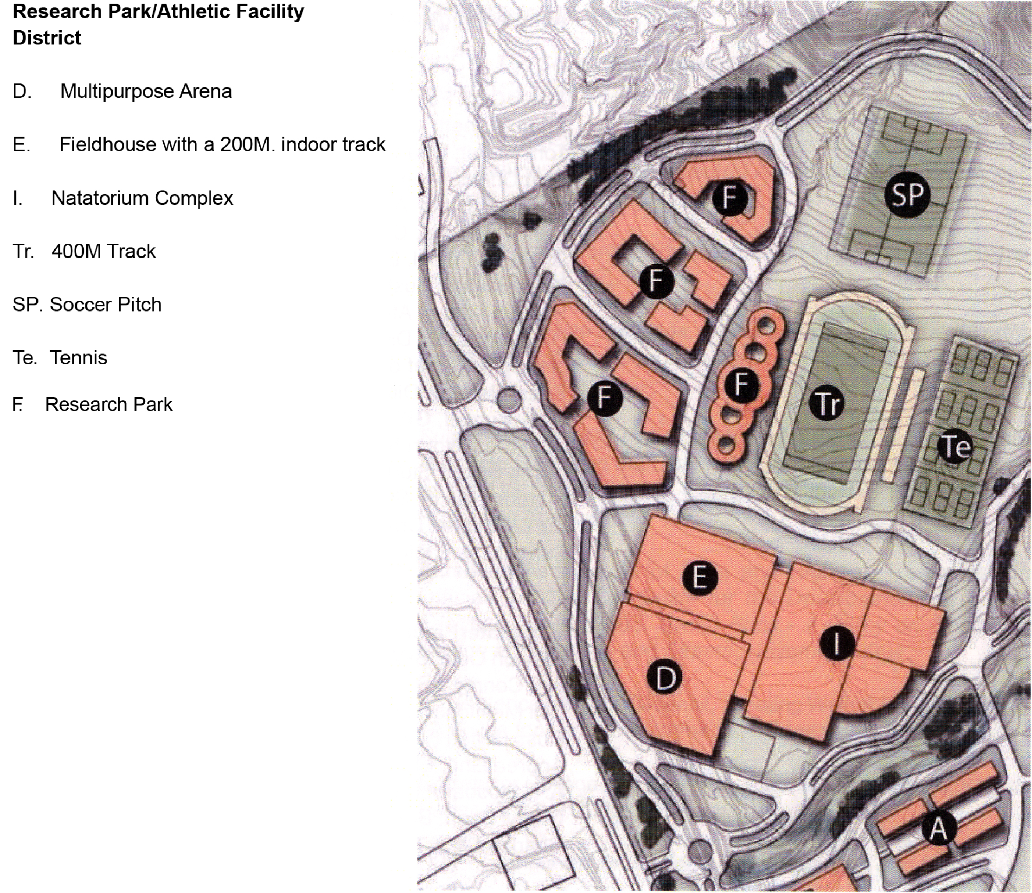

Research Park

Strategic Plan maps on pages 4.4 and above call for a Research Park to be developed at the northwest corner of the North Campus. These conceptual maps indicate that the land for the Research Park will be heavily developed. Thus, its “park-like” character must come from open land near it on the North Campus and from the beautiful Pulpit Rock formation and Park to the north. The Strategic Plan maps are not clear about the provisions for parking except that some will be accommodated on the streets. It is assumed there will be surface parking in the courtyards within the buildings and/or in on-site structured parking.

Design guidelines written for the Academic Villages should be followed on the Research Park. A distinctive entrance feature should be provided.

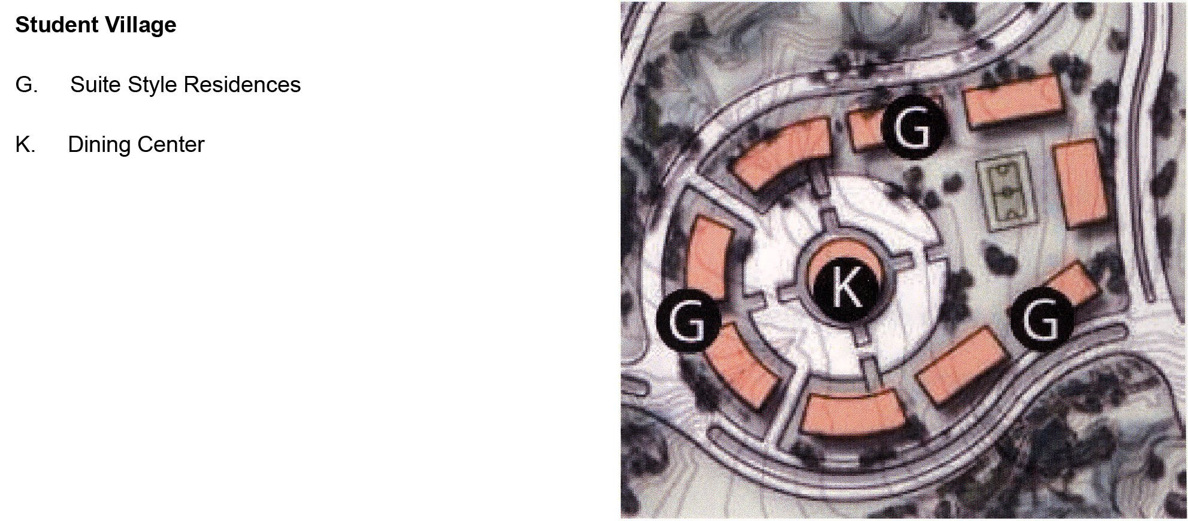

Student Housing Village

Located between two native arroyos of uncommon beauty, this cluster of student housing buildings offers a unique living opportunity for students.

Views of the distant mountains and the on-campus bluffs are everywhere and must be exploited by the designer in both siting and design of buildings.

In contrast to student residences in University Village, this housing village is seen as being almost rural … a village on a Colorado mountain bluff. Thus, we have created two distinct life styles in the Fifteen-Year Plan.

Academic Villages

Clusters of academic buildings are shown by the Facilities Strategic Plan north and south of University Village (see Plan on page 4.4). Parking is shown on the streets, as well as in courtyards within building blocks. Again, the configuration is fairly high density.

The buildings should follow the brick style with a mix of flat tan gravel aggregate and sloping tile roofs. There should be a variety of building heights. An interesting design vitality could be created by connecting some buildings at upper levels, bridging vehicular and/or pedestrian access ways to the courtyards.

THE WEST CAMPUS / GROWTH TO BUILD-OUT

Enrollment and program growth at UCCS is not expected to stop at 2021. If properly planned now, there may be space for limited construction within the present boundaries of the West and Central/East campuses. Significant growth may require land acquisition. These are matters that must be resolved sometime in the future.

For the present, campus planners must prepare designs that anticipate a fairly high density of development of the present campus land.

THE CAMPUS EDGE ON NEVADA AVENUE

While the campus edge along Austin Bluffs Parkway will present the academic face of UCCS for the most part, UCCS will present itself in a variety of ways along Nevada Avenue. The first view of the campus as one drives northward is at the intersection of Nevada and Austin Bluff Parkway. Here, the native landscape of the hillside creates an attractive regional view which is at ease with the bluffs in the background. The first entrance to the Campus from Nevada is at a traffic circle leading to an academic village (refer to the Campus Map on page 4.4) Then, the driver reaches a major intersection where the mixed-use University Village shakes hands with a large retail center planned west of Nevada Avenue. This is an important, very public entrance where UCCS offers performing arts, small retail shops and more. The next entrance invites the public to join audiences at indoor and outdoor sports events. The northern entrance offers yet another face of UCCS. This time it is the Research Park.

Adding to the complexity of the Nevada Avenue edge of the Campus is storm drainage which will play an important role in its design. The Campus map on page 1.5 illustrates the problem. The land on the entire North Campus slopes westward from the bluffs to Nevada Avenue. There are three large drainage basins flowing into three major outflows which cross under Nevada Avenue. An engineering study commissioned in 1998 by UCCS states:

“Basic civil drainage law places a natural easement upon lower lands for the drainage of surface water in its natural course and at natural flow levels. Liability issues arise when the downstream historic flows are increased due to development upstream. Acceptable solutions require either adequate downstream drainage facilities and easements for direct release of developed flows or utilizing detention facilities to regulate released flows at historic levels. This issue must be considered at all campus outfall point locations.”

The City of Colorado Springs requires suitable downstream facilities and easements for direct release of these developed flows or utilization of detention facilities to reduce flows to historic levels. Downstream drainage improvements would have to extend some 2,300 feet to reach Monument Creek to the west. On-campus detention facilities could require large low-land areas, which would serve as storm water collection ponds, but would otherwise remain dry.

As the North Campus is developed, hard surface (paving and rooftops) will replace soil which absorbs storm water making today’s drainage problems even more demanding.

Storm drainage solutions could exert considerable impact upon the appearance of the west edge of the Campus. If detention ponds are required, they must be incorporated into its design. The Strategic Plan page 4.4 fails to provide land reservations for them. Prior to venturing design recommendations for the Nevada edge of the Campus, further studies by UCCS, the City and the developers of the retail center west of Nevada are needed.

While it is possible that landscaped, low lying detention ponds must be located between Nevada and the on-campus frontage road, one thing is clear. The four entrances from Nevada to the Campus must be beautifully landscaped and contain appropriate campus signage.

The Nevada frontage must not disappoint. It will require much study.

THE HELLER CENTER

The Heller Center is a residential-artists studio enclave gifted to the University in 1997. Reached by a rutted road extending northward from the Eagle Rock neighborhood, the complex contains five small buildings: a house, guest house, studio, art gallery, and a garage. There is only minimum site development. A photograph of the buildings as they were in perhaps the late 1940s is on page 3.12.

The sparsely developed Heller Center is a village of its own—a rustic place not seen elsewhere on the UCCS campus. The land-use restrictions placed on the Heller Center Parcel are considerable. Designs are currently underway for development of this project.

In compliance with the donor’s wishes, the Heller Center will become a quiet place where artists and others will gather to learn from each other. It will host events ranging from retreats, conferences and seminars to plein-air painting sessions.

